**University of Engineering and Management, Kolkata**

**NEWTOWN, RAJARHAT**



**Database Management System LABORATORY**

**NAME : Shubham Dutta**

**CLASS : CS-2B**

**YEAR : 2ND YEAR**

**SEMESTER : 4th SEMESTER**

**SECTION : 2B**

**ROLL NO. : 58**

**ENROLLMENT : 12019009022112**

Assignment -4

Q1. Show the values of departmental table.

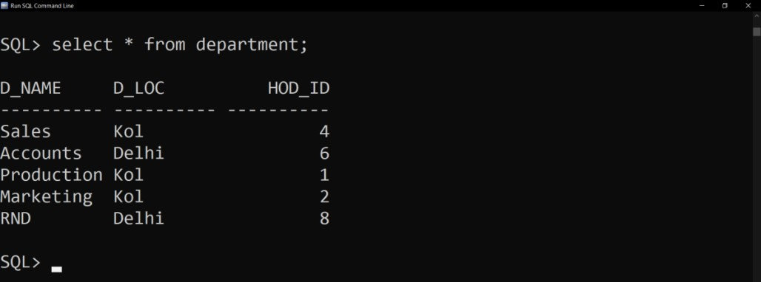

Q2. Select the department names and their locations.

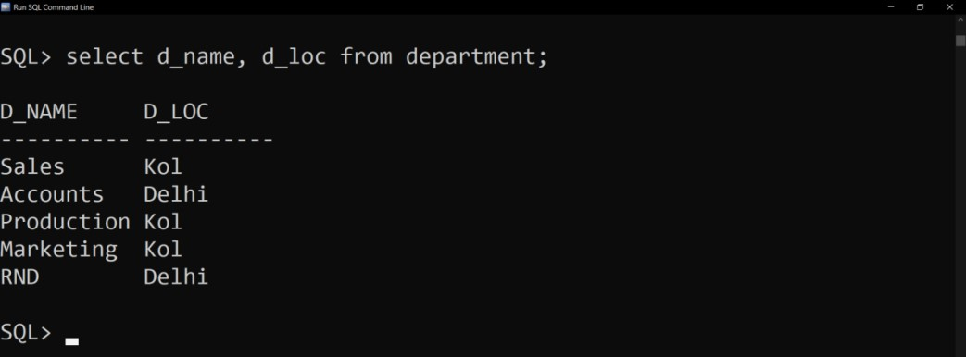

Q3. Show the employees f_name ,l_name , salary and the salary after 1000rs. Bonus.

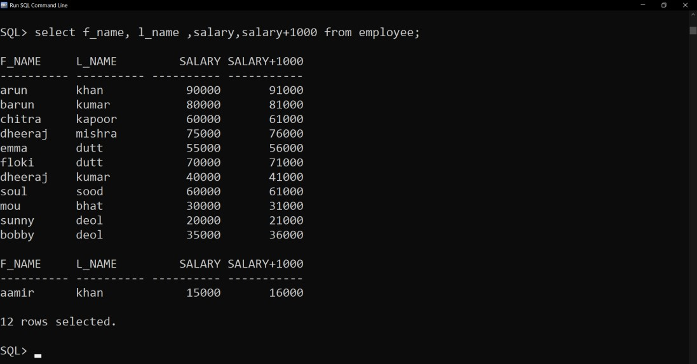

Q4. Show the employees annual salary with a 1000rs. Yearly bonus and the annual salary with a 100rs. Monthly bonus.

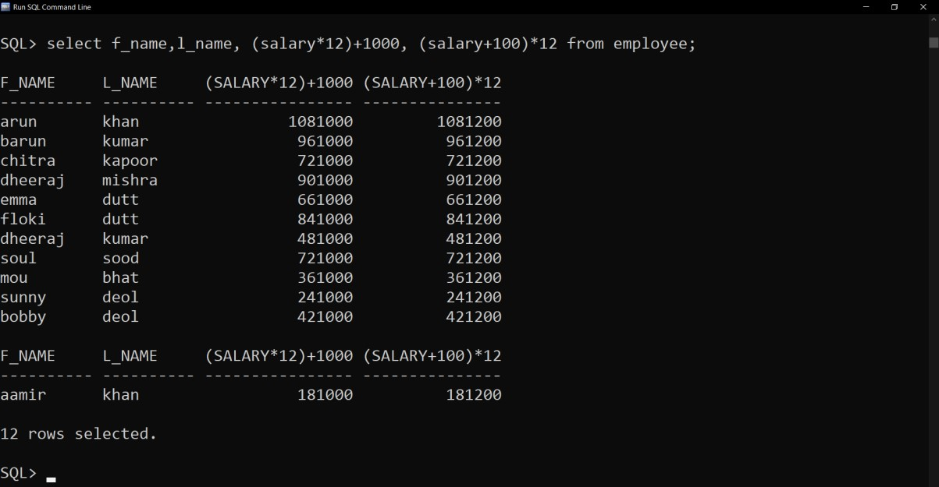

Q5. Show f_name as NAME and annual salary as ANNSAL from the employee table.

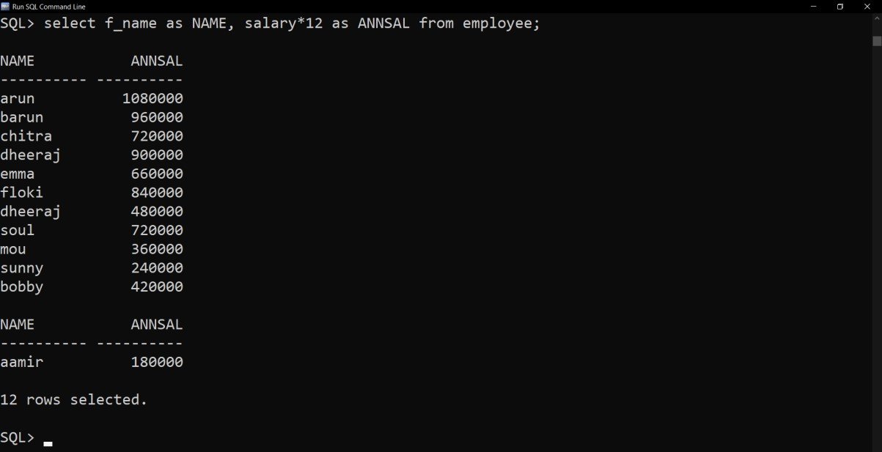

Q6. Show the l_name as LasT AND 100rs. Incremented salary as NewSal.

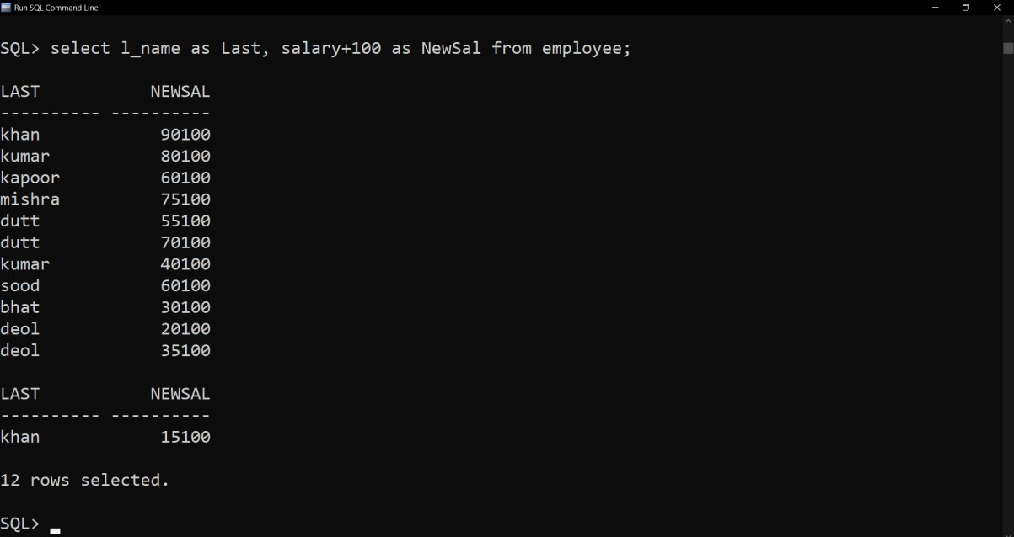

Q7. Show the emp_id, f_name, l_name, job_type of the employee getting highest salary.

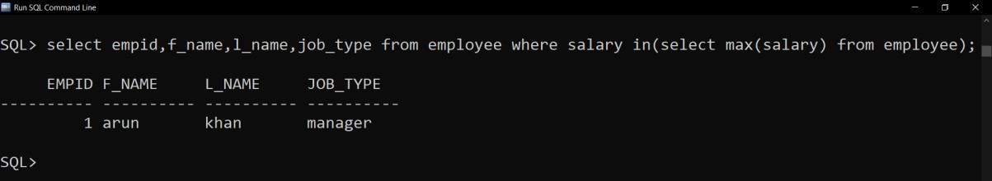

Q8. Show the emp_id, f_name, l_name, job_type of the employee getting minimum salary.

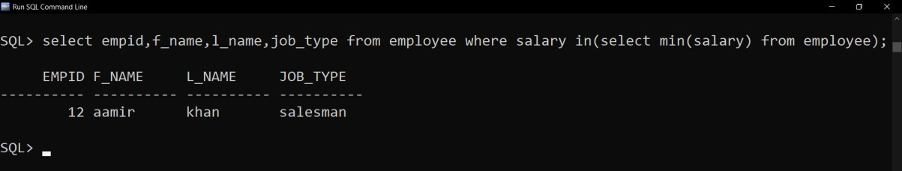

Q9. Show the average salary of employees in the employee table.

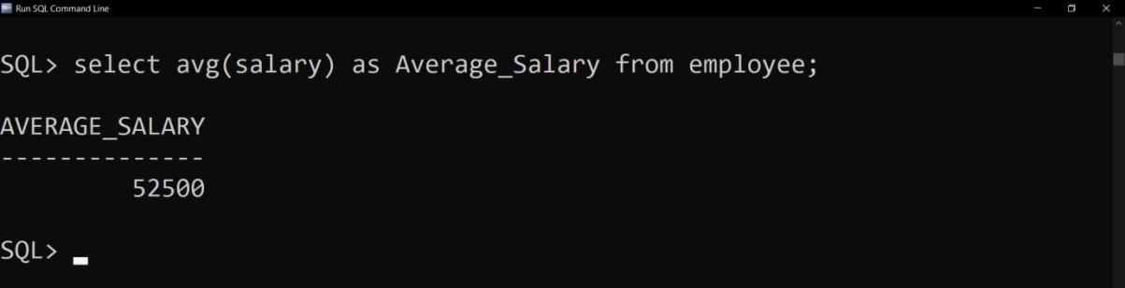

Q10. Show f_name, l_name and job_type as employees.

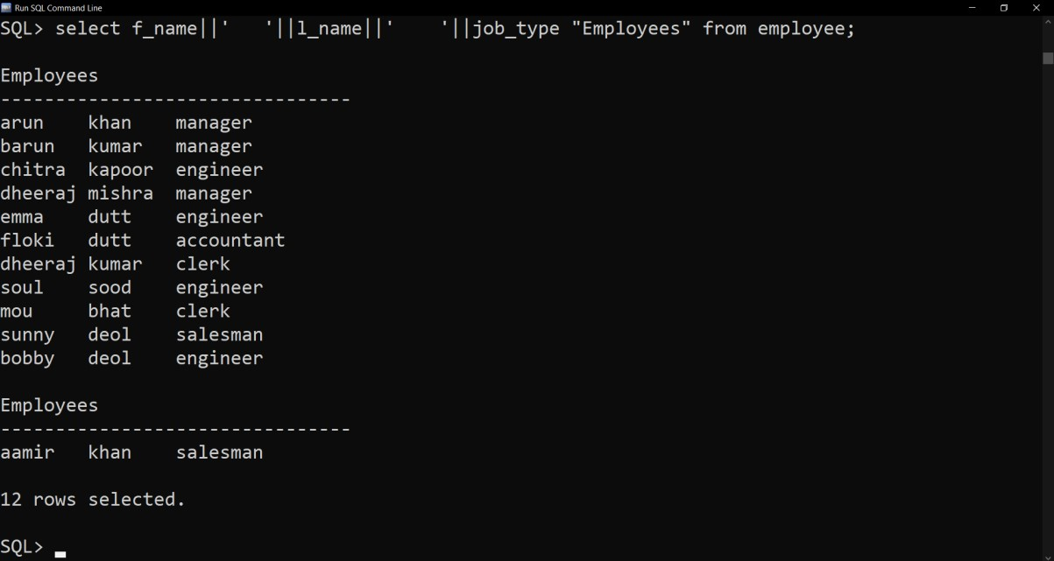

Q11. Show employee details in the following fashion.



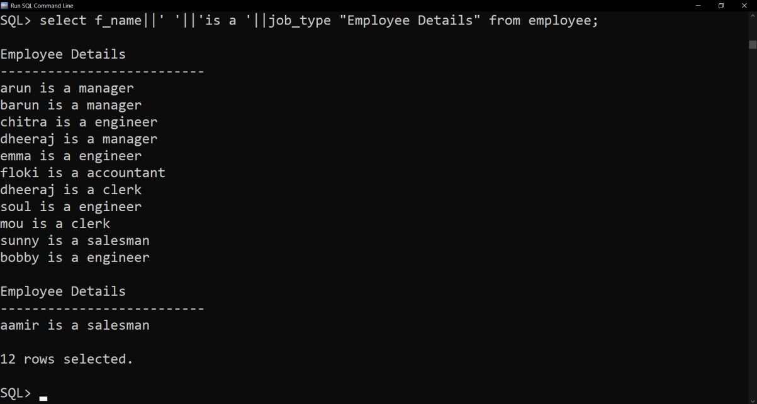

Q12.

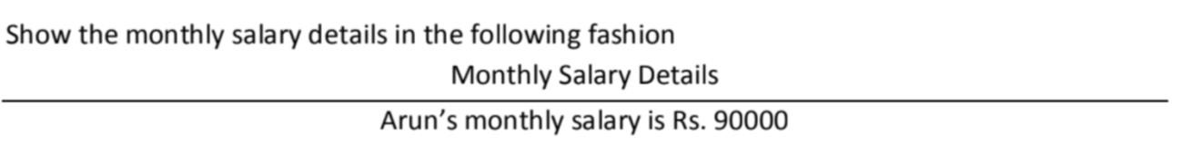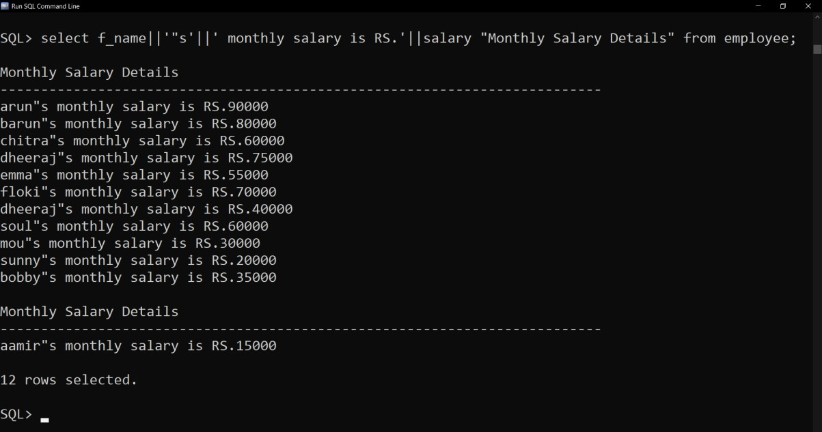

Q13. Show the different department names from department table.

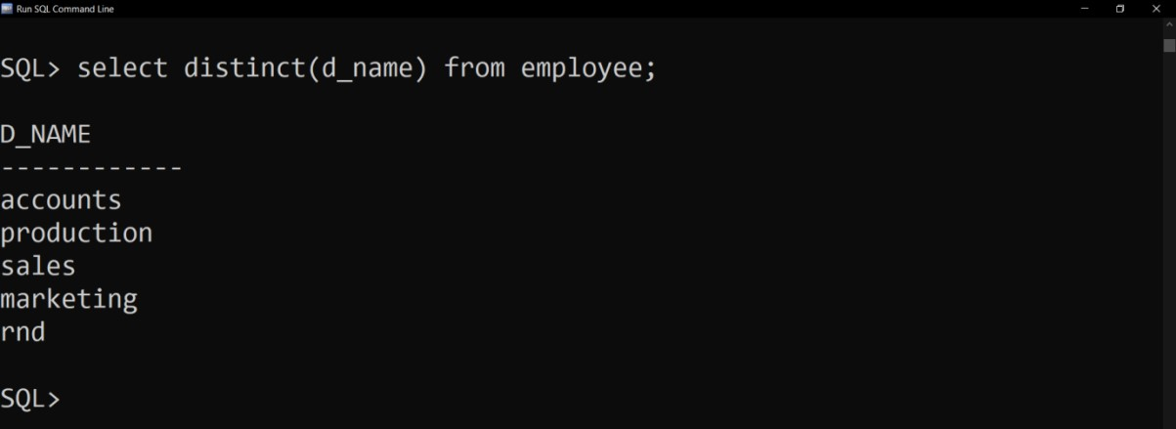

Q14. Show the employee names who works in ‘Sales’.

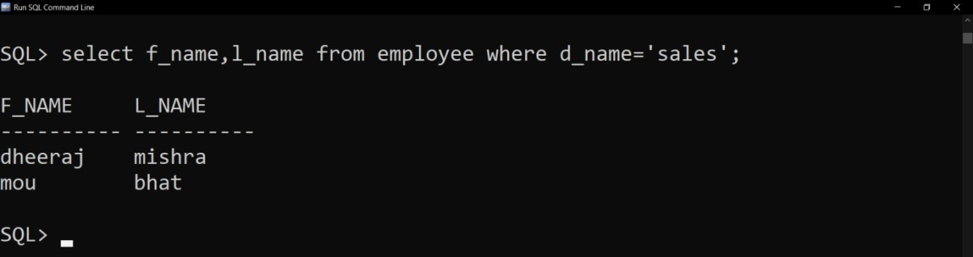

Q15. Show the employee names who gets salary of more than 50000 per month.

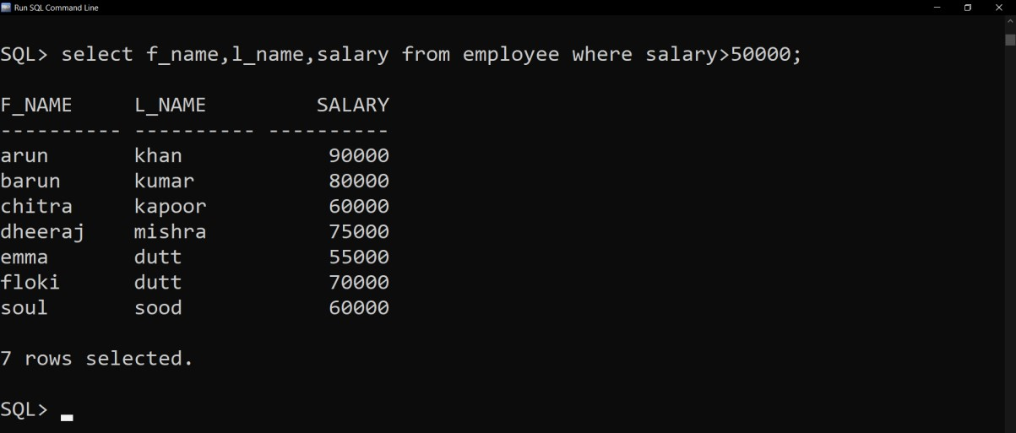

Q16. Show the details of the employee whose manager id is not 1.

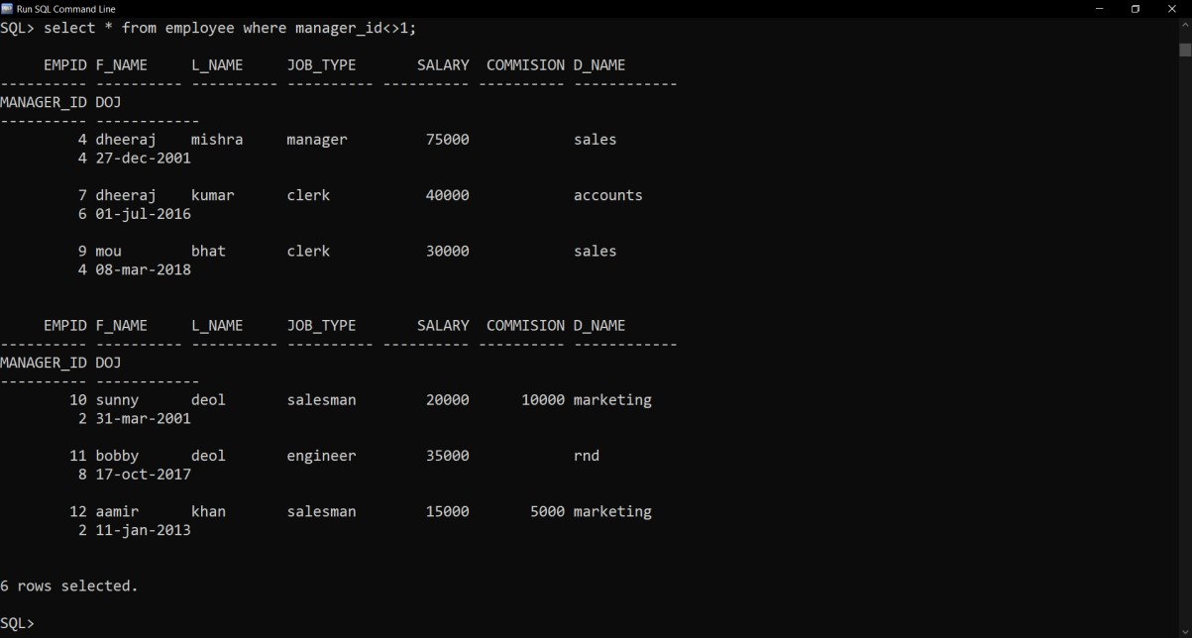

Q17. Show the employee details whose salary ranges between 40000 and 70000.

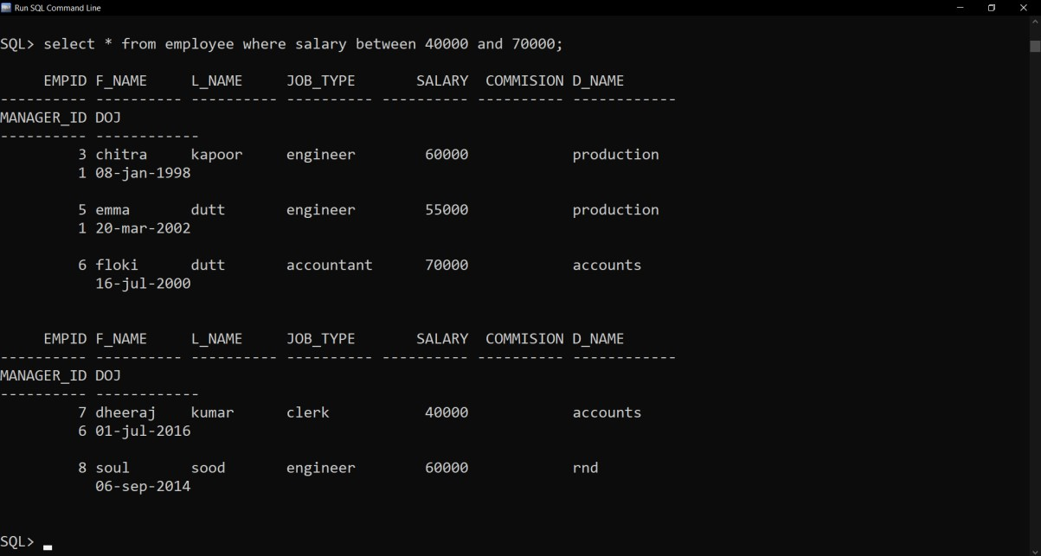

Q18. Show the details of the employees who works under the manager having id 1, 6 and 8.

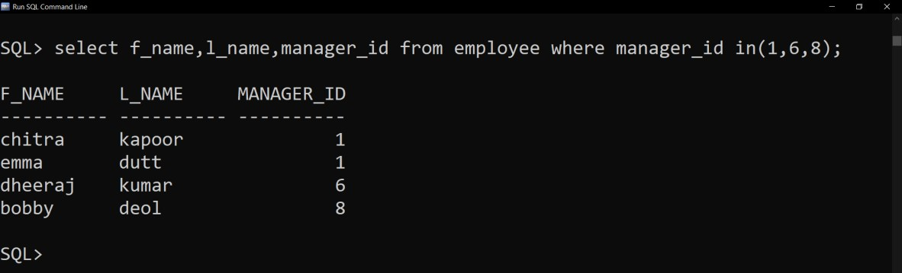

Q19. Select the f_name and salary of those employees whose last name starts with ‘K’.

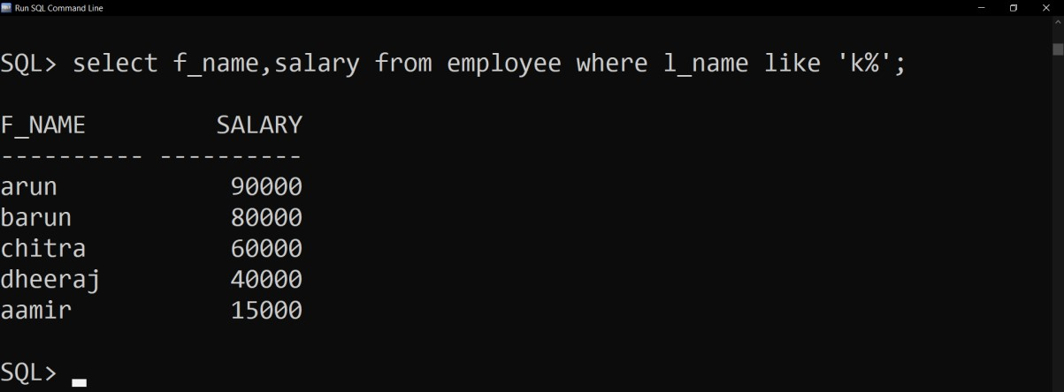

Q20. Select the f_name and salary of those employees whose last name starts with ‘K’ and ends with ‘R’.

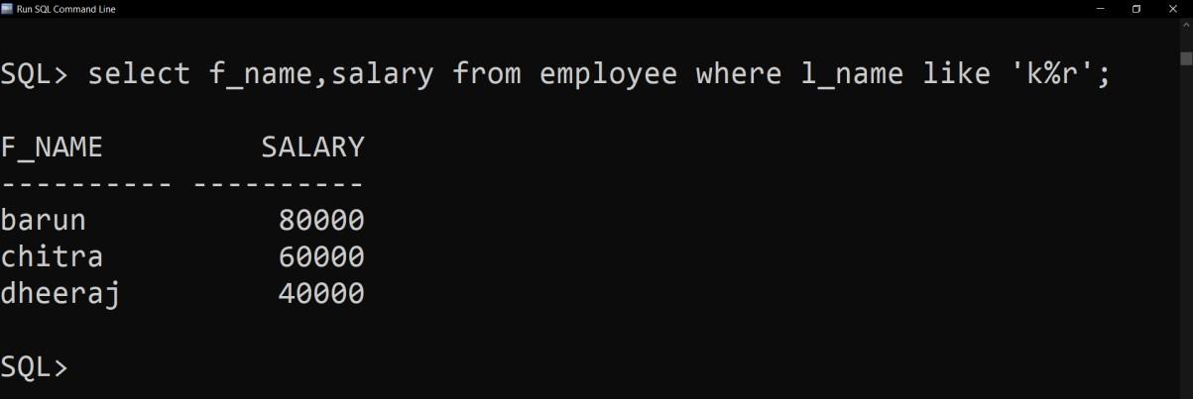

Q21. Show the details of those employees where 3rd letter of l_name is ‘o’.

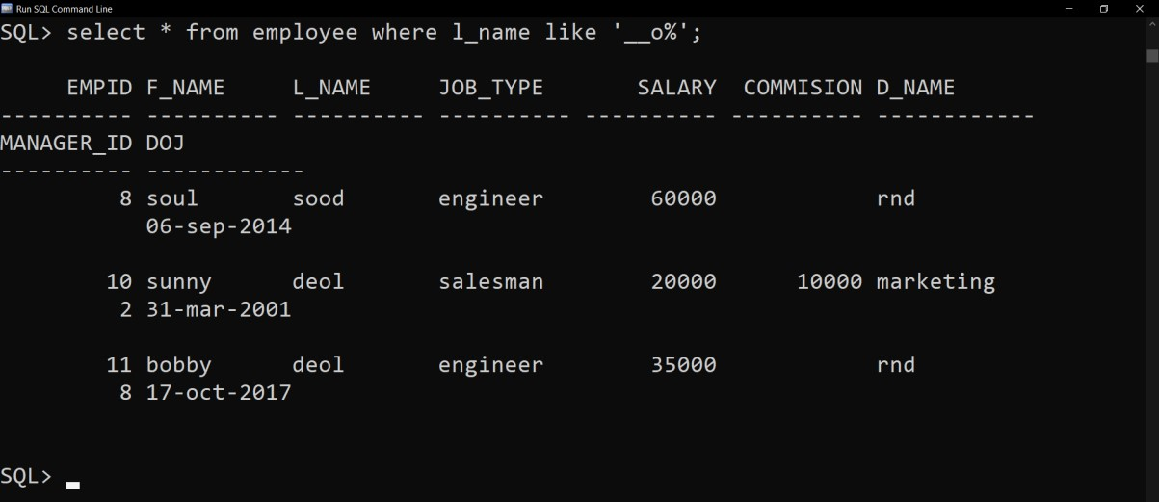

Q22. Select the details of those employees who works as an engineer with monthly salary more than 50000.

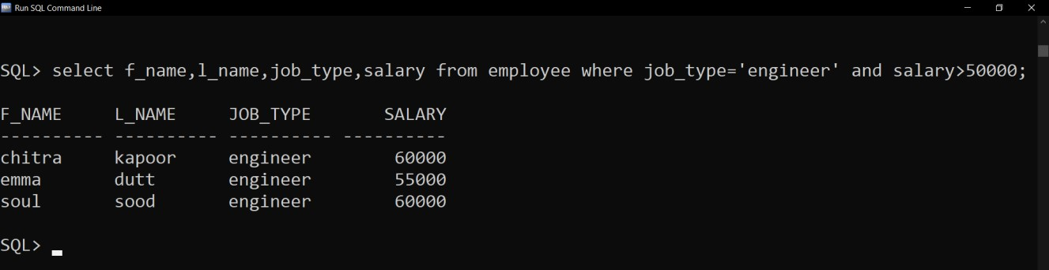

Q23. Select the employees whose department is ‘Production’ or monthly salary is more than 60000 per month.

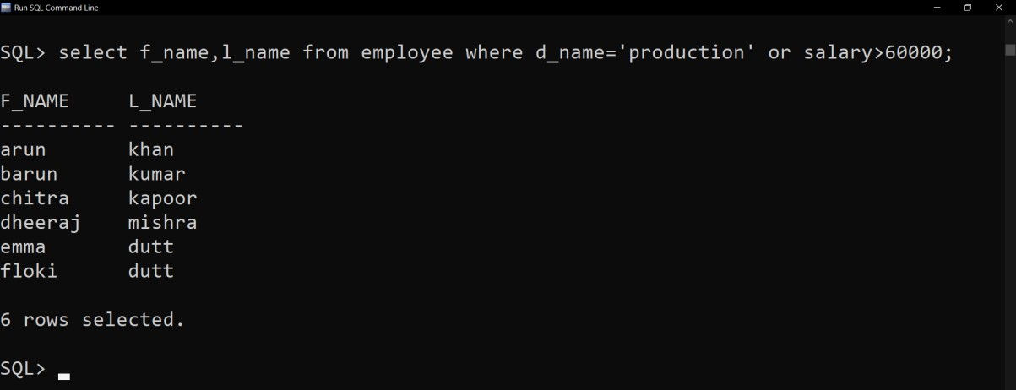

Q24. Show the use of upper and lower function.

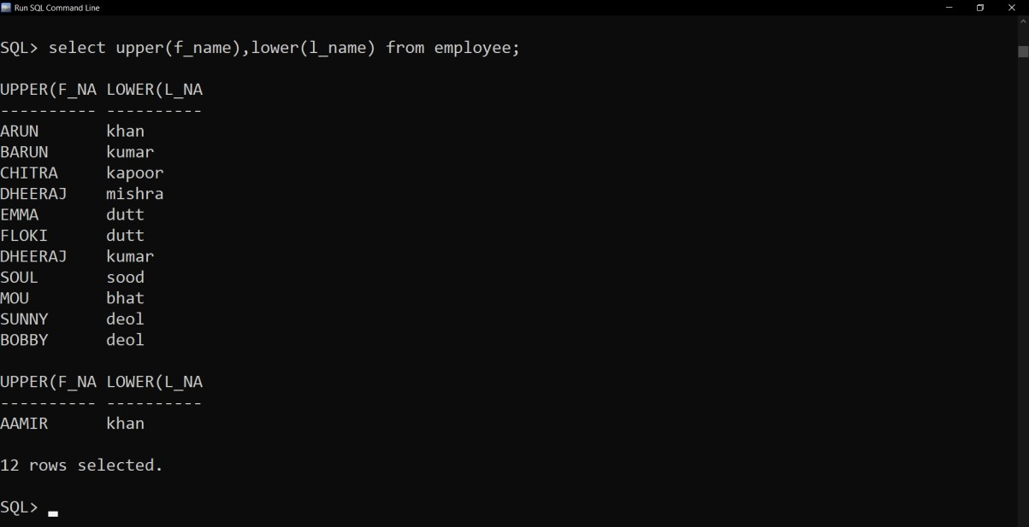

Q25. Show the use of concat, instr and length function.

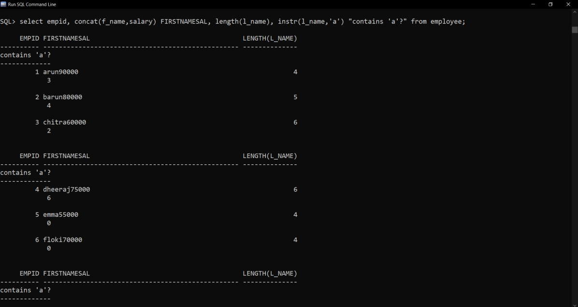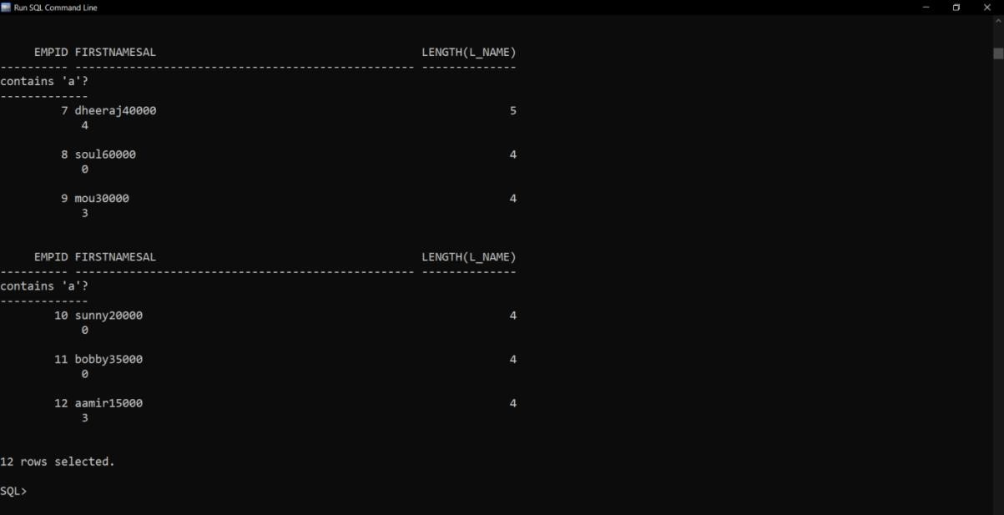

Q26.

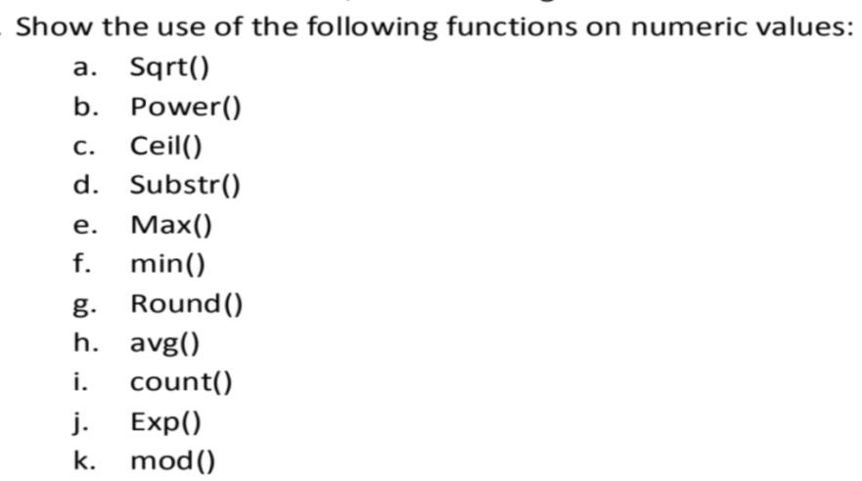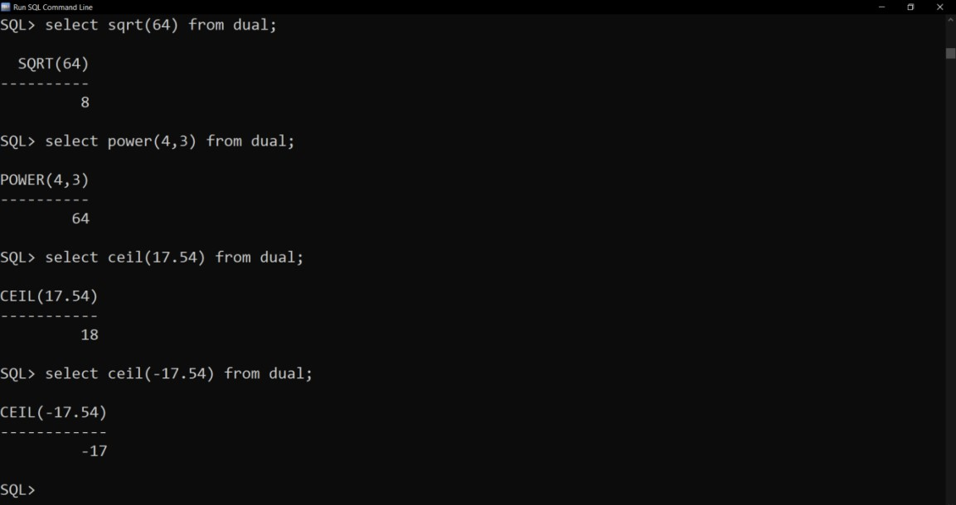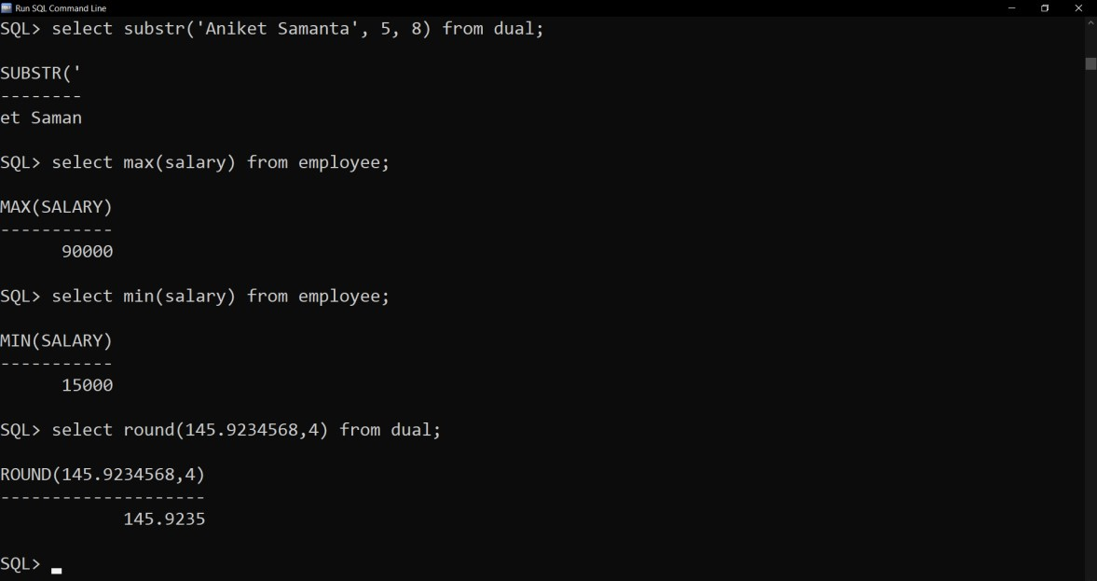

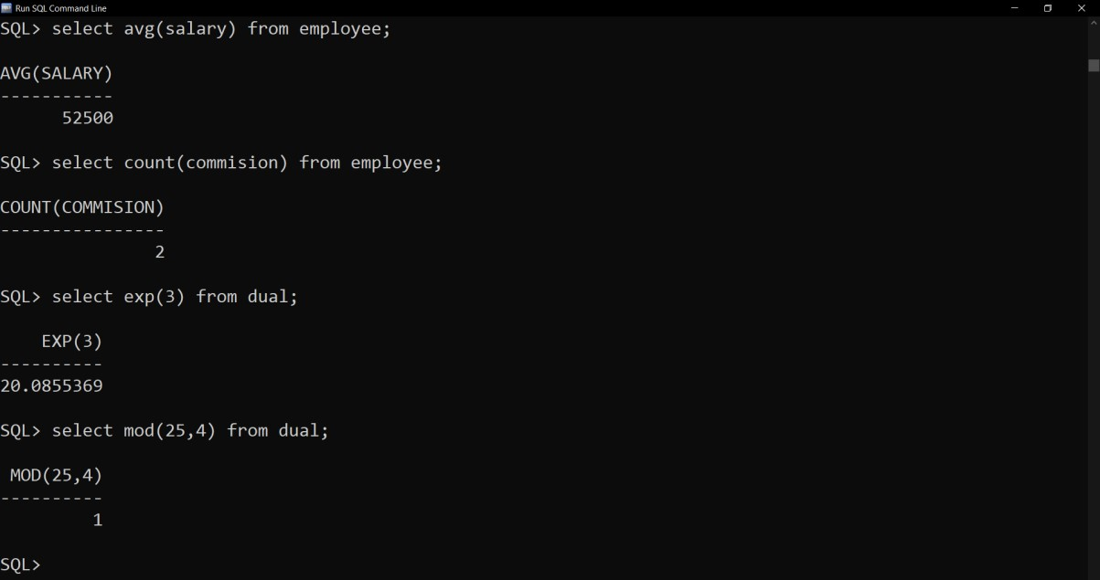

Q27.

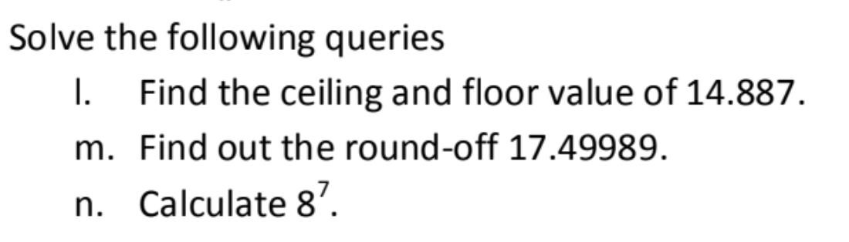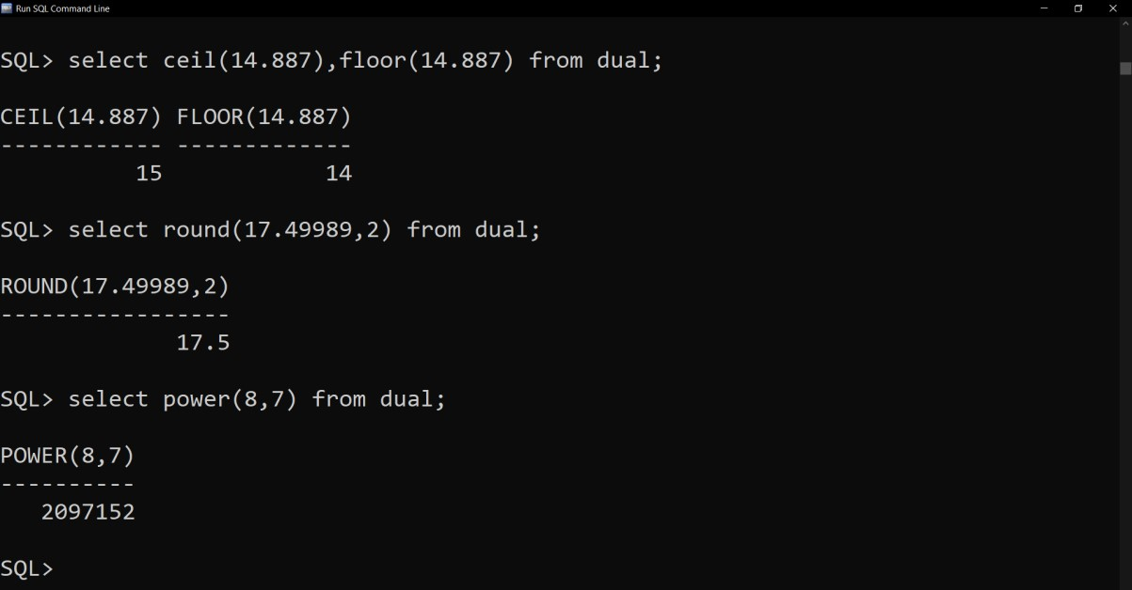

Q28. Show the current date.

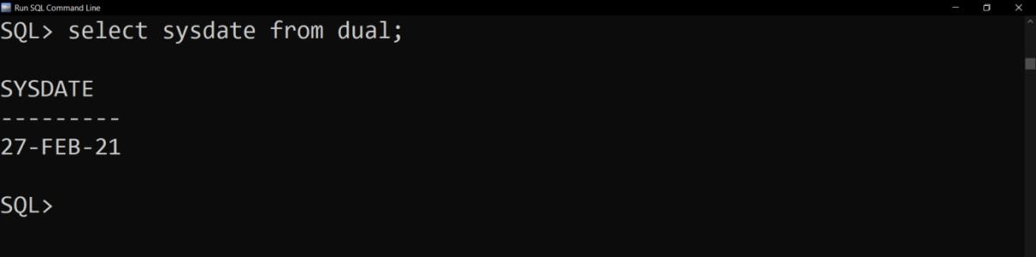

Q29. Find the total experience of the employees in weeks who works in Sales department.

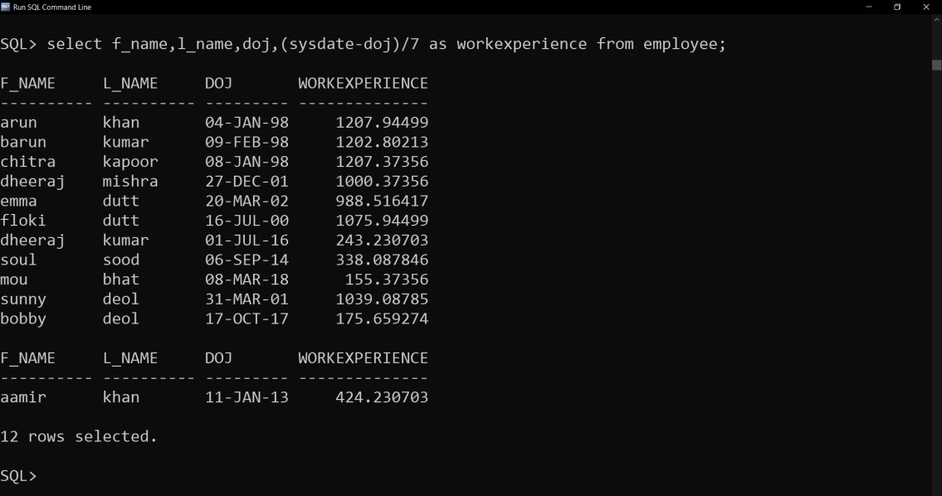

Q30. Display the use of the following functions on date

1. Months_between
2. Add_months
3. Next_day
4. Last_day
5. Round
6. Trunc
7. To_char

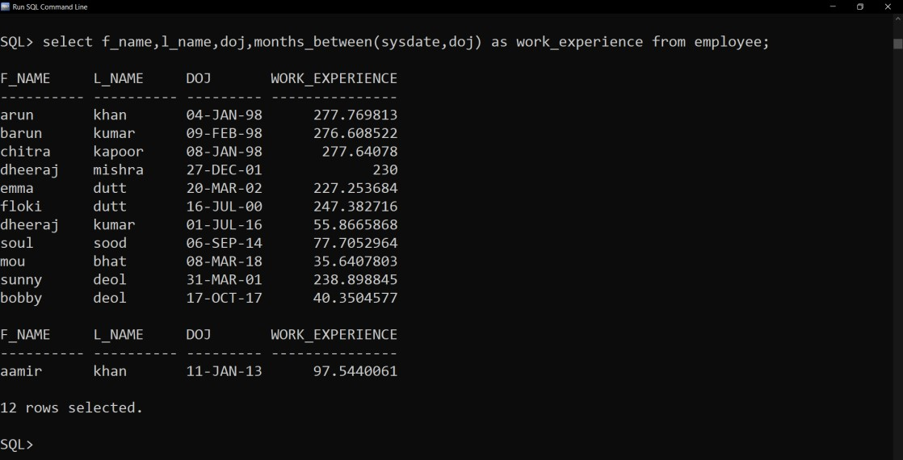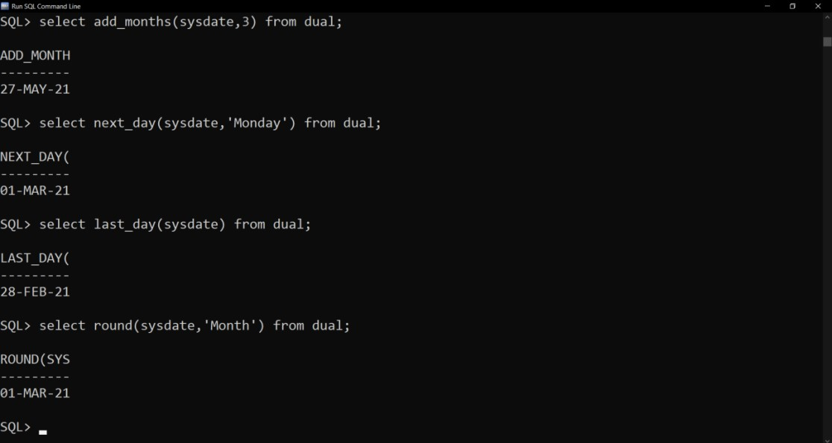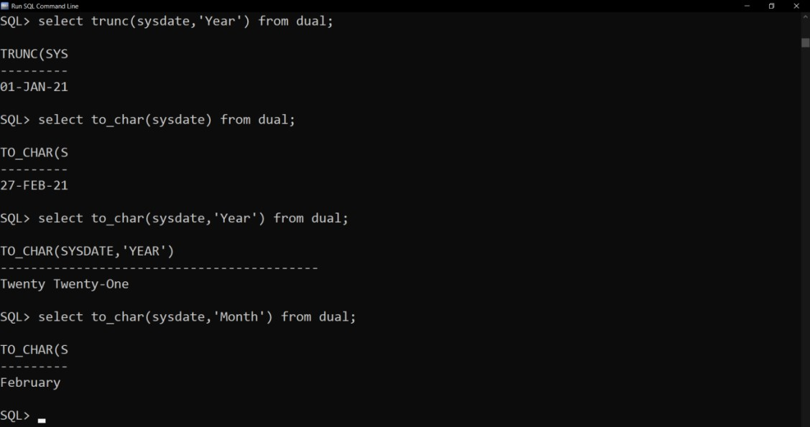

Q31.

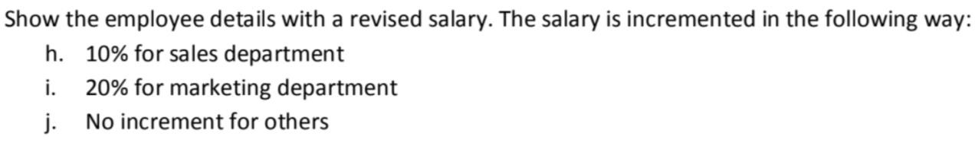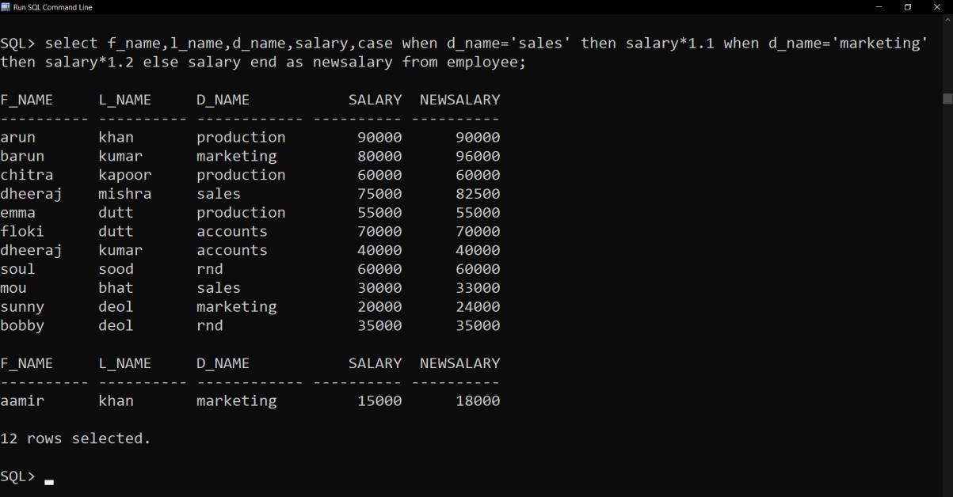

Q32. Determine the tax for each employee in production department based on the monthly salary. The tax rate are as per the following data:

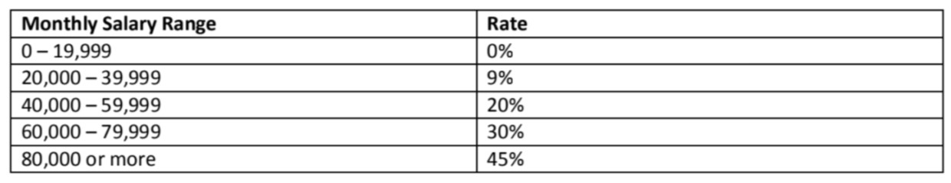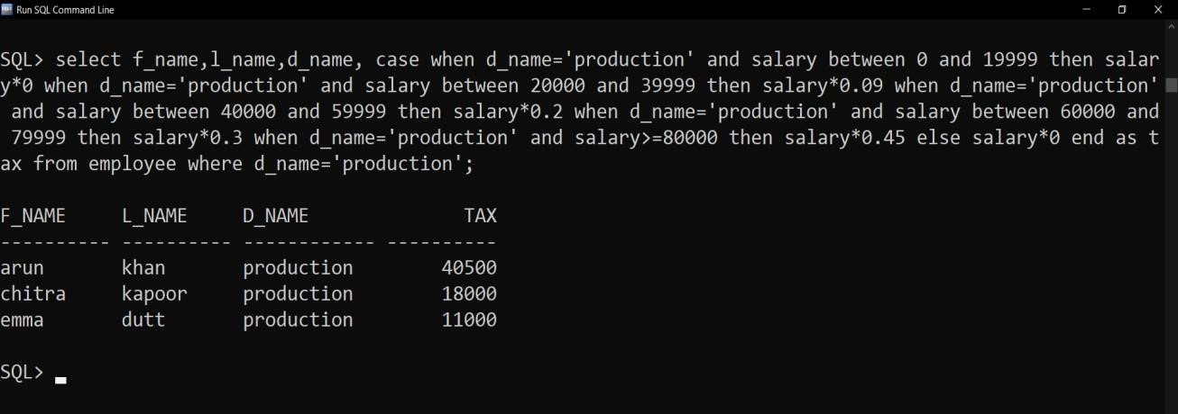

Q33. Find the Cartesian product between Employee and Department table.

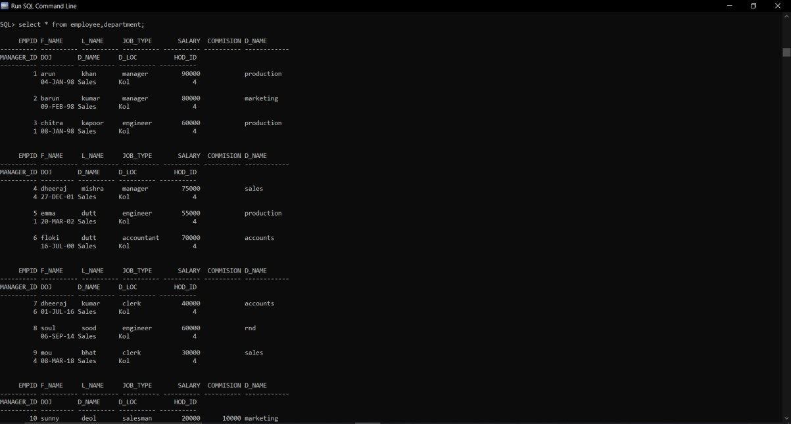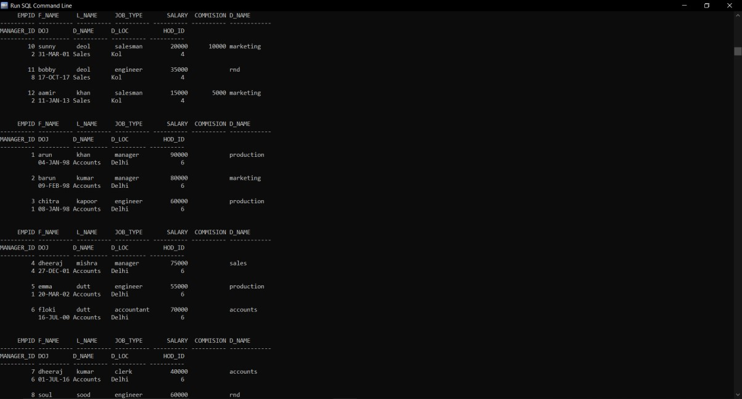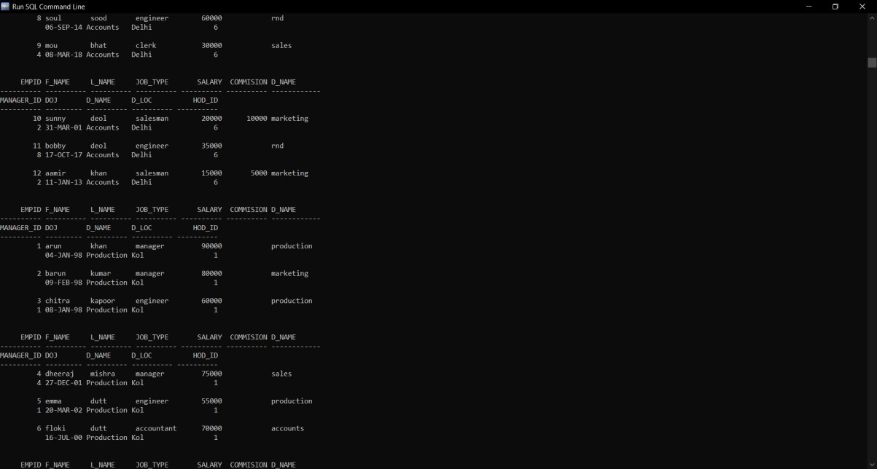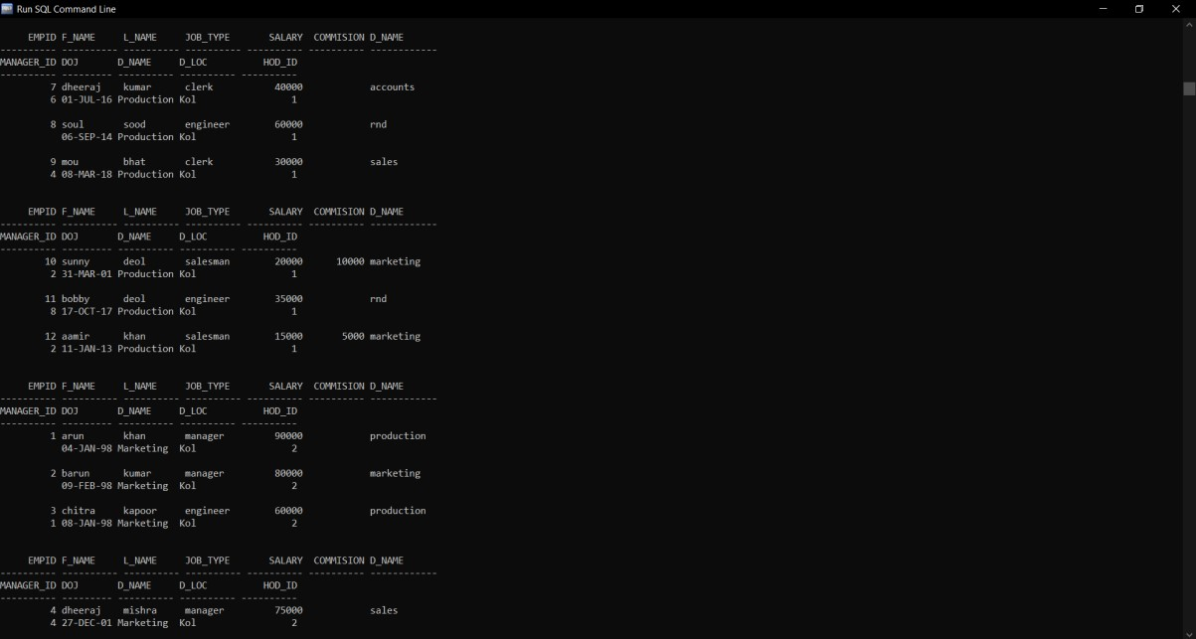

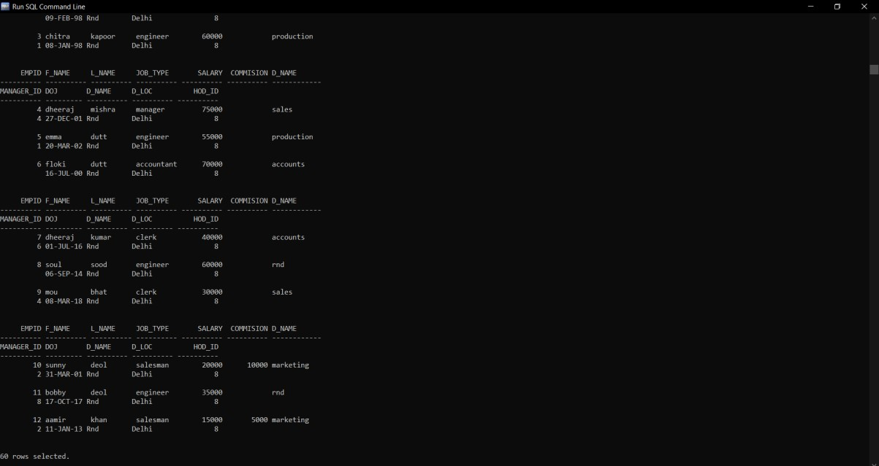

Q34. Show the employee names and the respective department location.

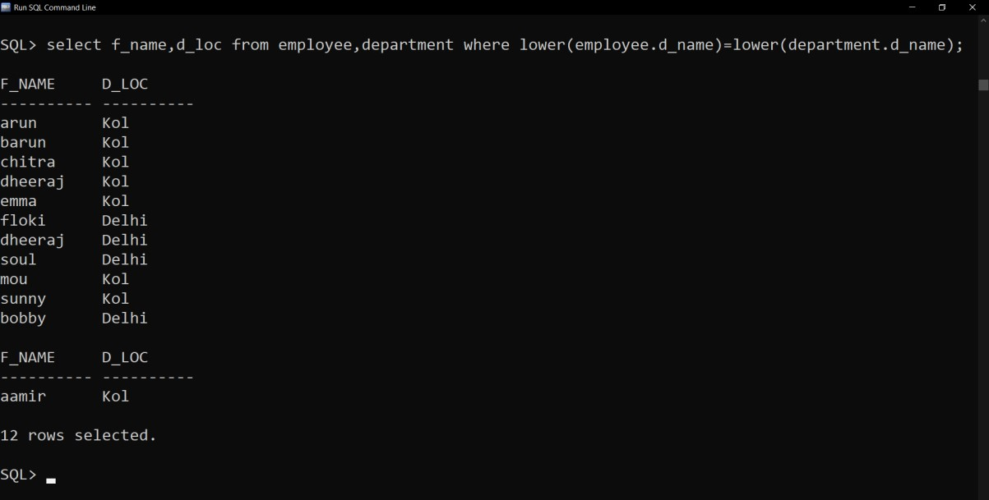

Q38. Find the employee name and date of joining who are working in Delhi.

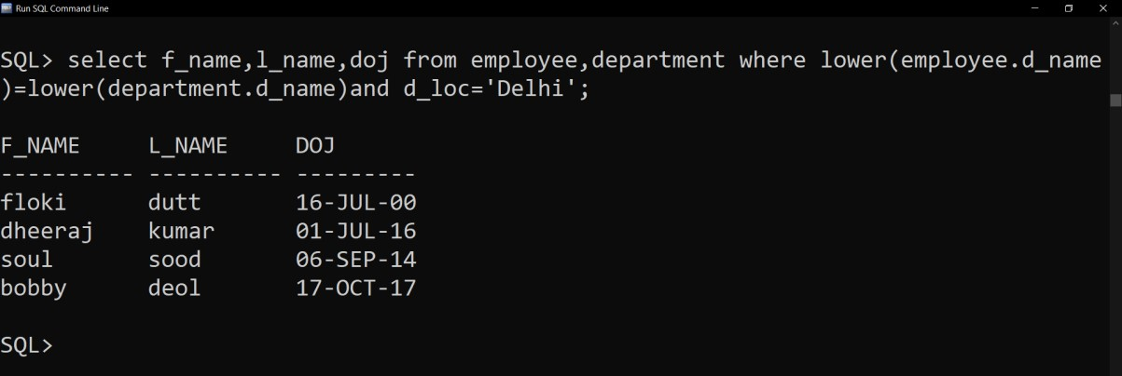

Q39. Create a table ‘Emp_Address’ for storing the permanent address of the employees and insert the following values:

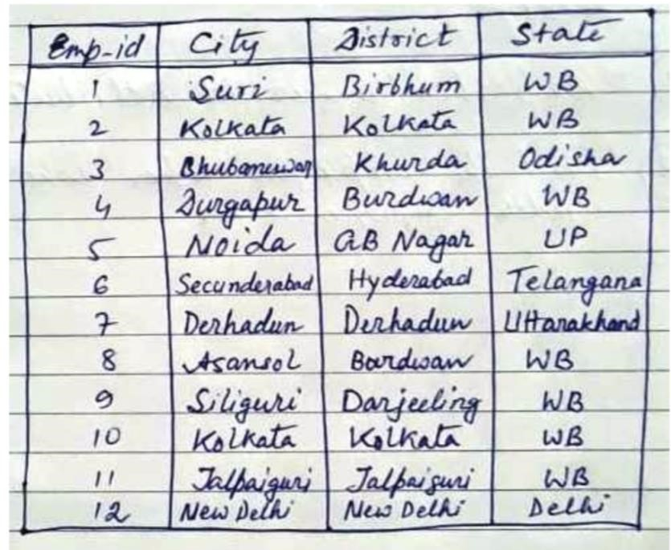

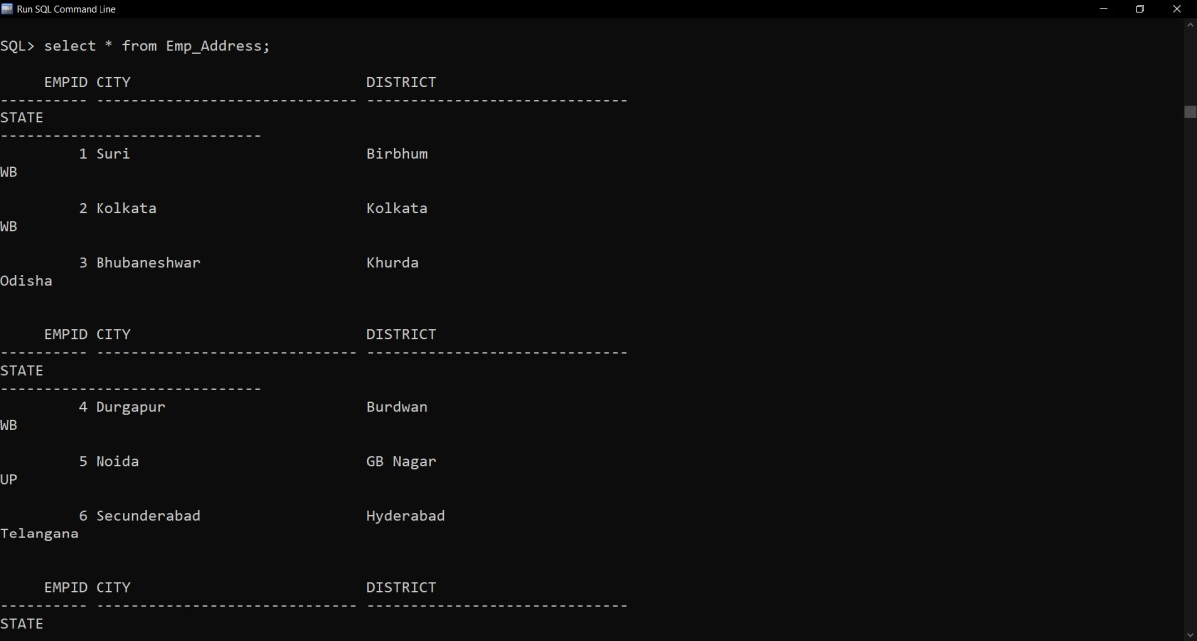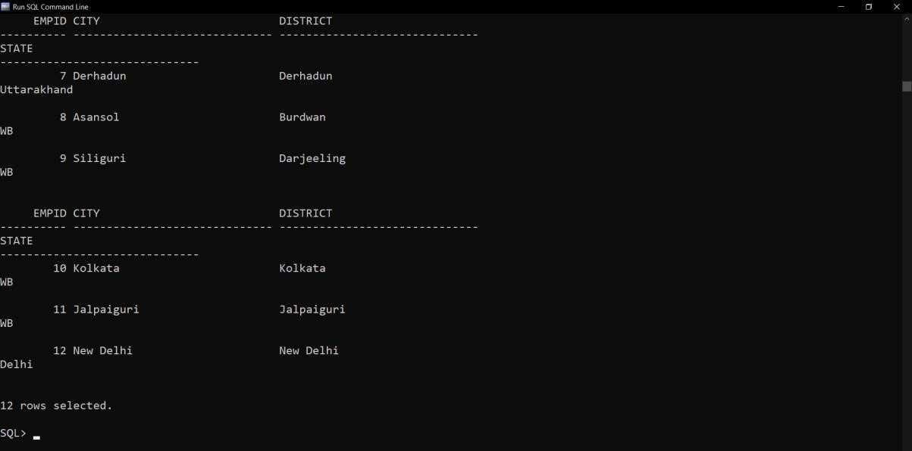

Q40. Display the name of employees, department location and the city name the employee belongs to, from the Employee, Department and Emp_Address tables.

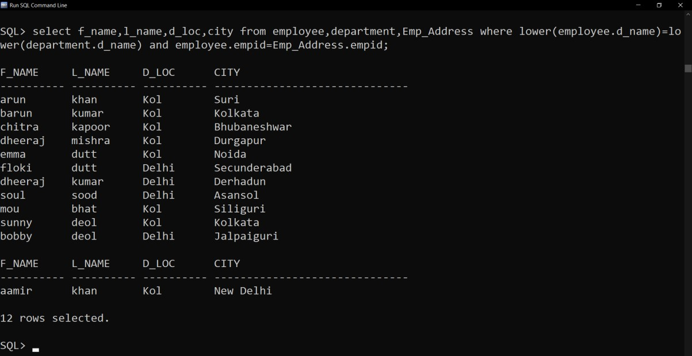

Q41. Find the name of each department’s manager.

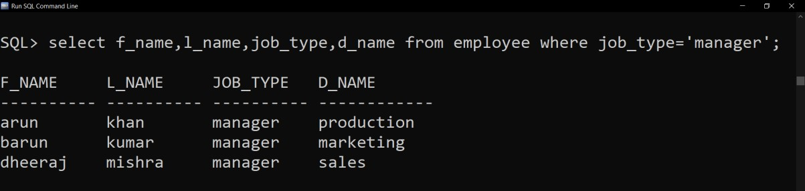

Q42. Create ‘Job_Grades’ table and insert the following values:

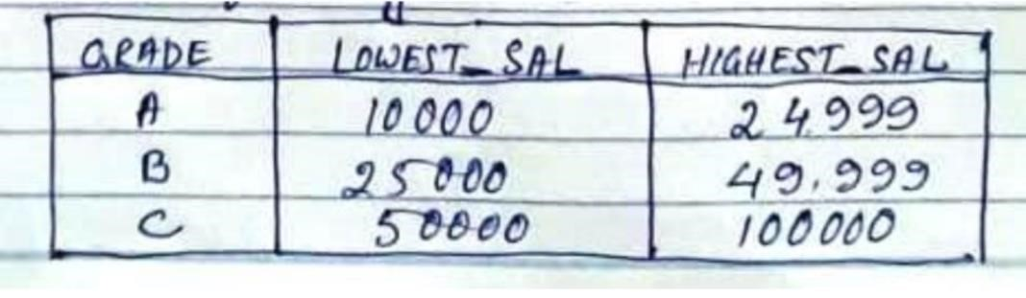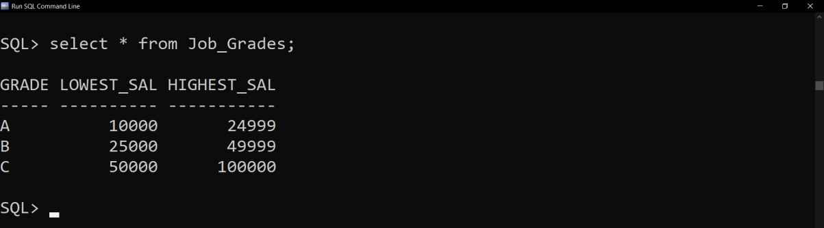

Q43. Display the employee names with their respective job grades and salary.

